# Documents Generated:

Copy a previous quote: This general for all quotes.

Documents generated:

Quote Letter and Supplemental application

Now, let’s bind the policy

It generates a new policy number, new documents (binder letter, invoice) and LES reports

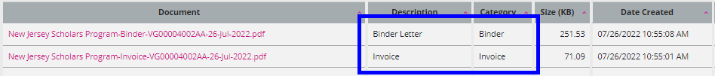

Now, let’s issue the policy

History:

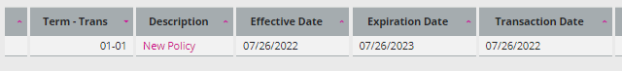

Documents:

LES: No new entry.

**Revised Policy:**

You must use the policy Effective Date.

VG00004002AA

Initial documents Supplemental Application, Quote Letter, Binder Letter, Invoice, Policy Declaration.

Click on amend icon and select Revised Policy and then click on Continue.

In this example, I changed the Quote Options from $1200 to $1320

History:

Documents:

This generates a Binder Letter, Invoice and Policy Declaration

The invoice shows the full premium

LES:

Revised Binder:

Status: Bound

History:



Documents:

LES:

Let’s amend the quote and perform a revised binder… No change in the date. In this example only will change the premium in Quote Options.

This will show the difference in the UI

Save and Exit

History:

Documents:

Generated two new documents (Binder Letter and Invoice)

LES:

This creates an Error Correction and a New Business

In the invoice, it shows the entire premium after the revised binder is done.

**MTA:**

I need to specify since when the change will take place. It can be the same effective date or different.

If you need to add/delete an endorsement you **must** use an MTA.

Initial History:

Initial Documents:

MTA:

In this example I will add an endorsement and change the expiration date.

Save and Exit

New History:



New Documents: Invoice and Policy Declaration

LES:

In this case it had BMT + GL so you can see two New business and Two Error corrections, and then you will see the Additional Premium.

When you do an MTA the invoice will show only the difference in the premium

